**Attendance Management System**

1. **Login Page**

User can type username and password provided. User roles are divided as admin and registered user. Basic validations done to check username and passwords.(Only admin has a admin role in the users list).

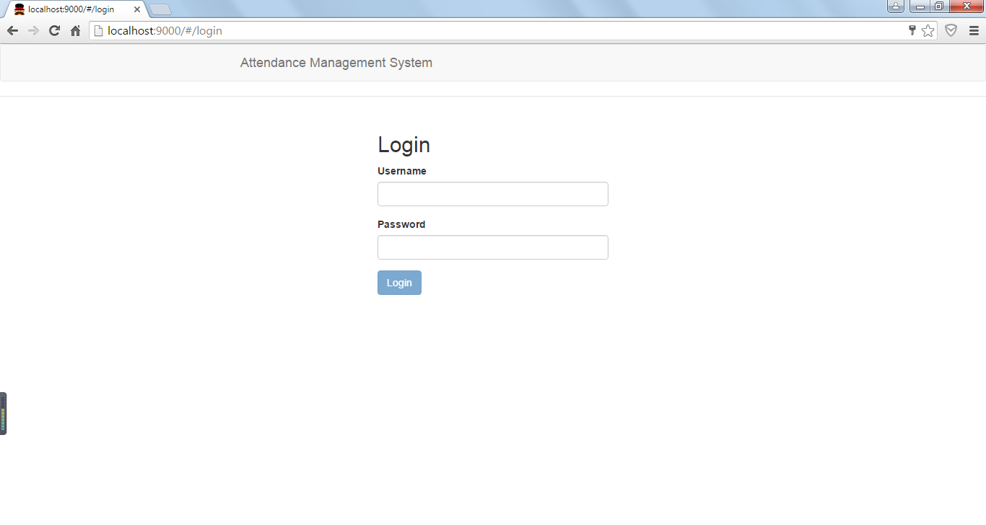

1. **Home Page (Admin User)**

After Login admin user can see all the registered users and can also delete the users. Admin user can also see registered users attendance filtered with date or name. Admin user can delete the users and can also add new users.

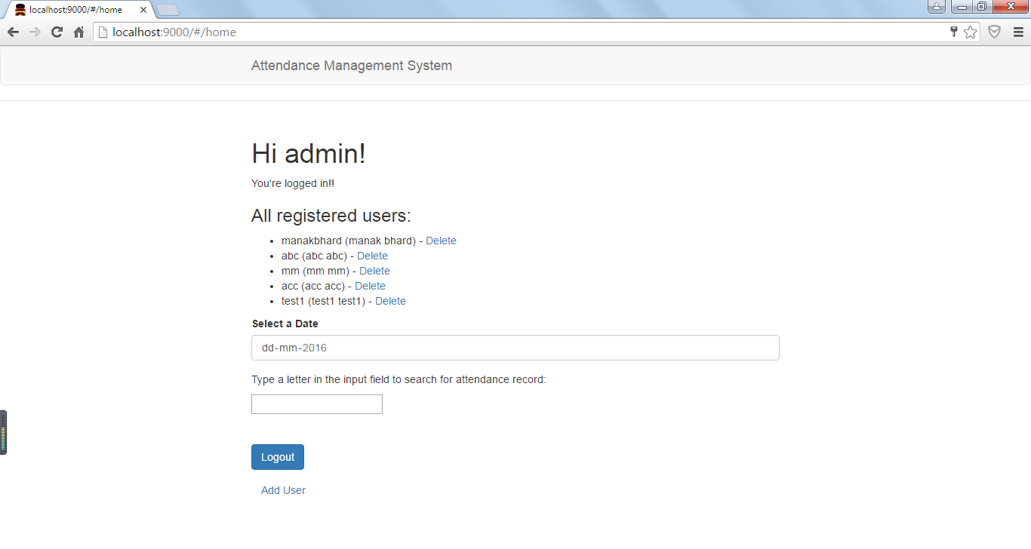

With username filter and showing the attendance record.

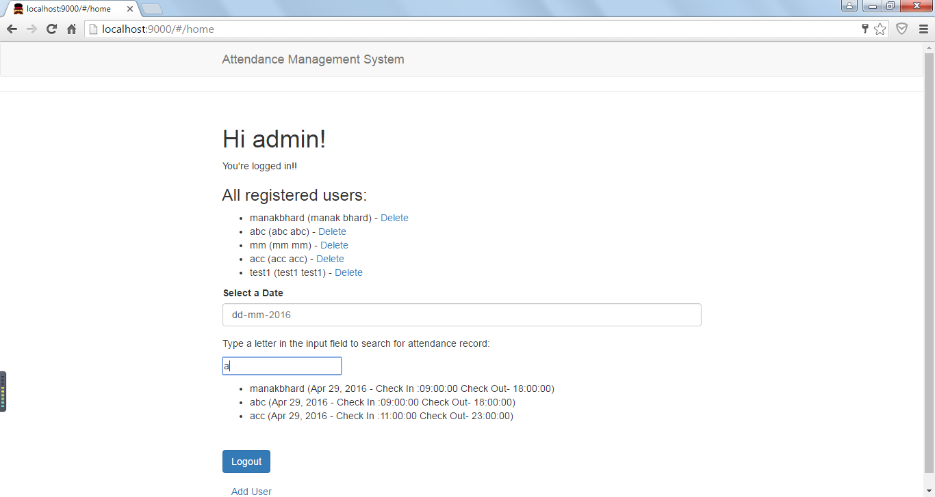

1. **Add User (Admin User)**

When user clicks on Add User on Home Page it user reaches to register user page. Admin User can add new user by giving basic info. All the fields are required

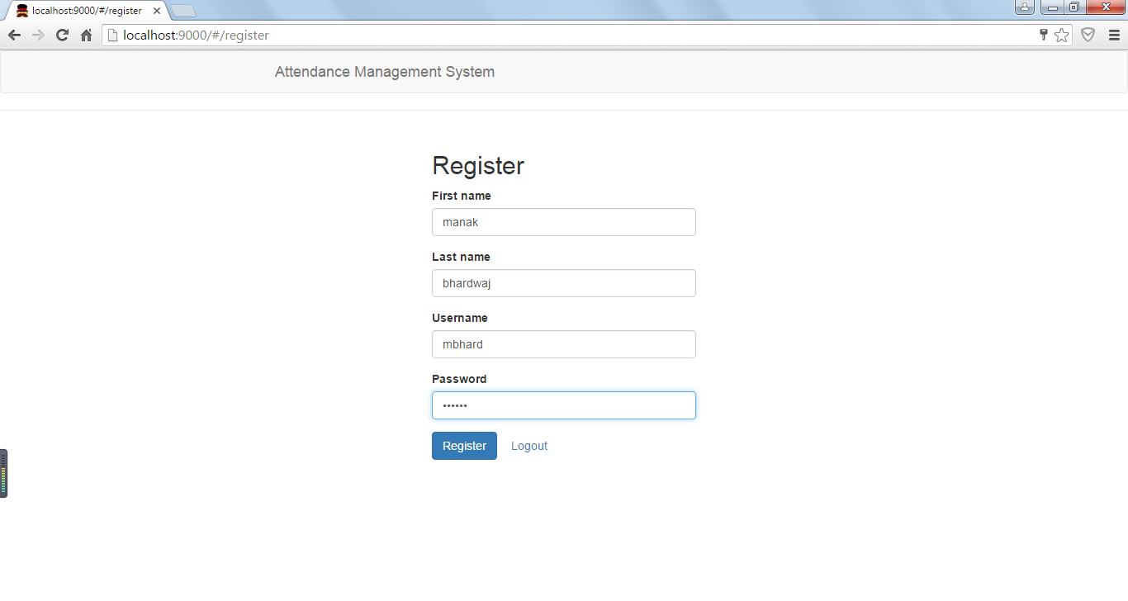

After registering the user it came back to home page and can see new username in the list.

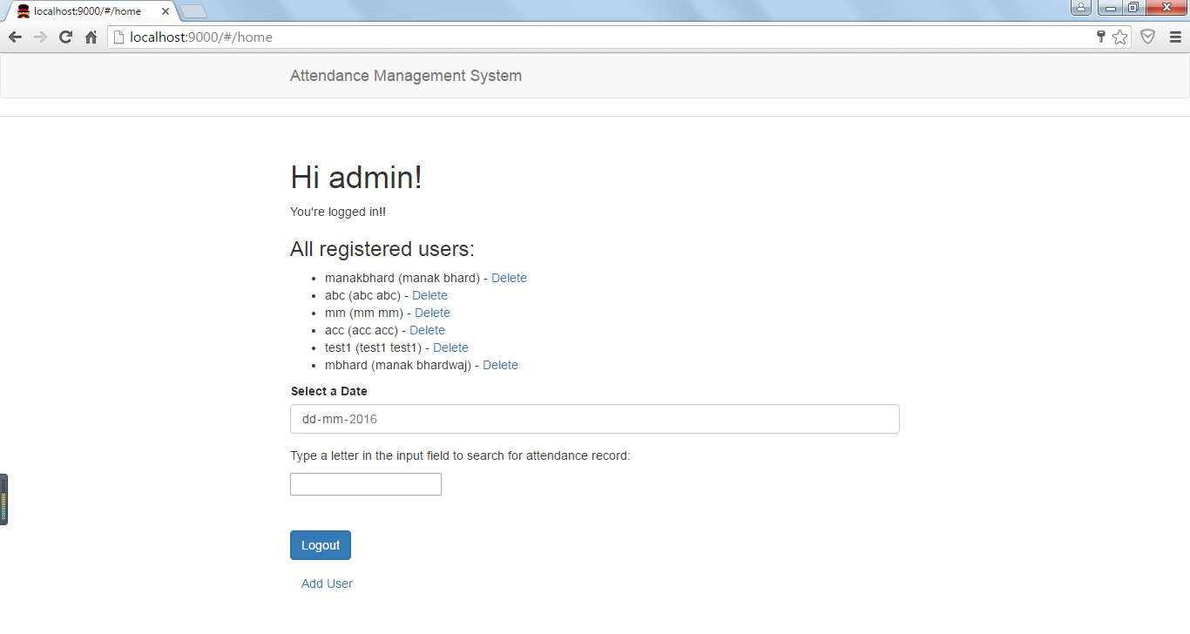

User can logout and will land on Login Page.

1. **User view Page (Non Admin User)**

After Logging into the application with the username and password provided. Non Admin Users will land on User view page where user can save the attendance for the day. Start Time and End Time will appear once date is selected.

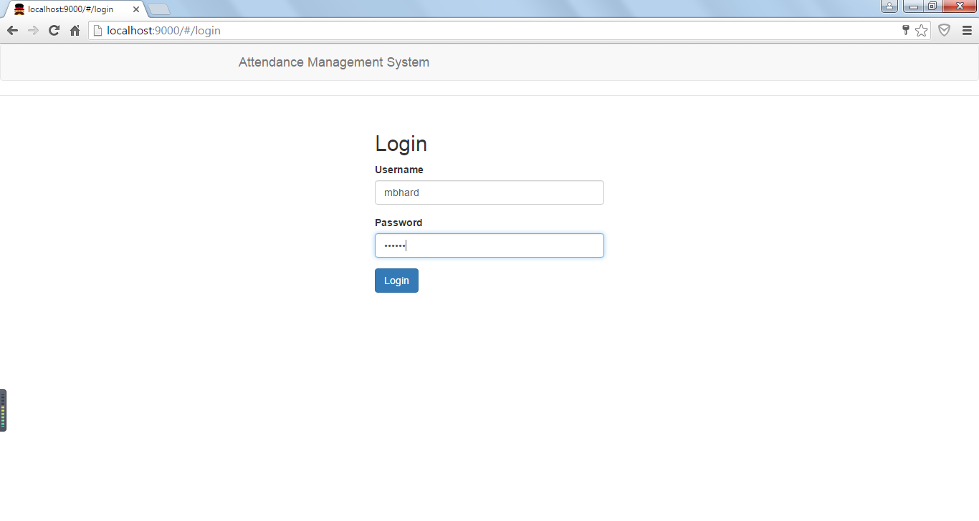

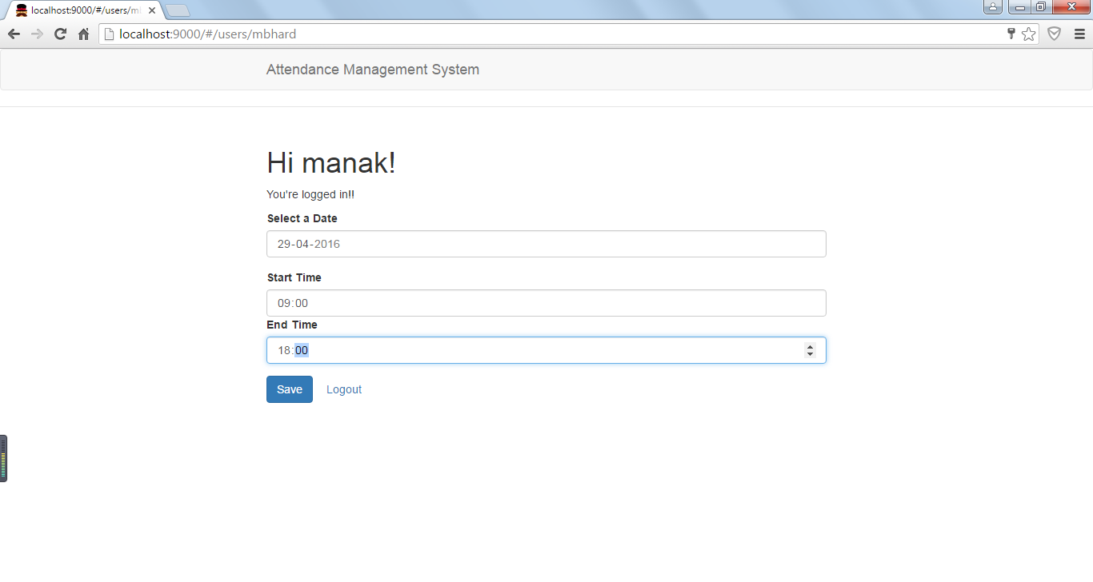

After Saving the information , attendance record will be displayed to the user.

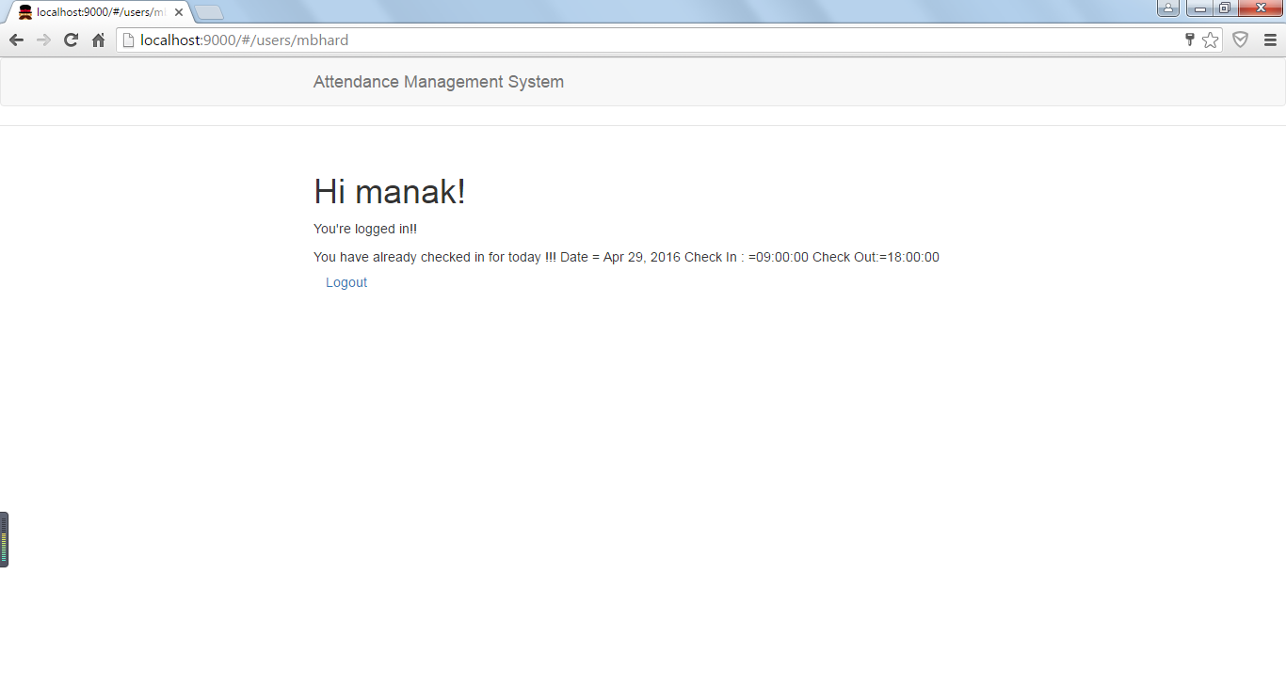

Issues and minor changes not resolved

1. angular.js:13550 Error: [ngModel:datefmt] Expected `2016-04-28T18:30:00.000Z` to be a date----Done
2. Some more features left to be done -----Once Above two issues are done I ll start working on these, Also I haven’t used Angular.material as not able to learn that.--Done
3. Please share what more features left if not mentioned